**Project Title:** Traffic Analysis for Society Commute and Congestion Management

**Objective:** Analyze car movements in and out of a society during peak hours and evaluate traffic congestion trends to suggest improvements.

**Dataset:** A synthetic dataset containing timestamps, number of cars going out, number of cars coming in, total cars, and congestion levels.

1. **Import the Dataset into PostgreSQL  
   A: Create a table with name Traffic Data**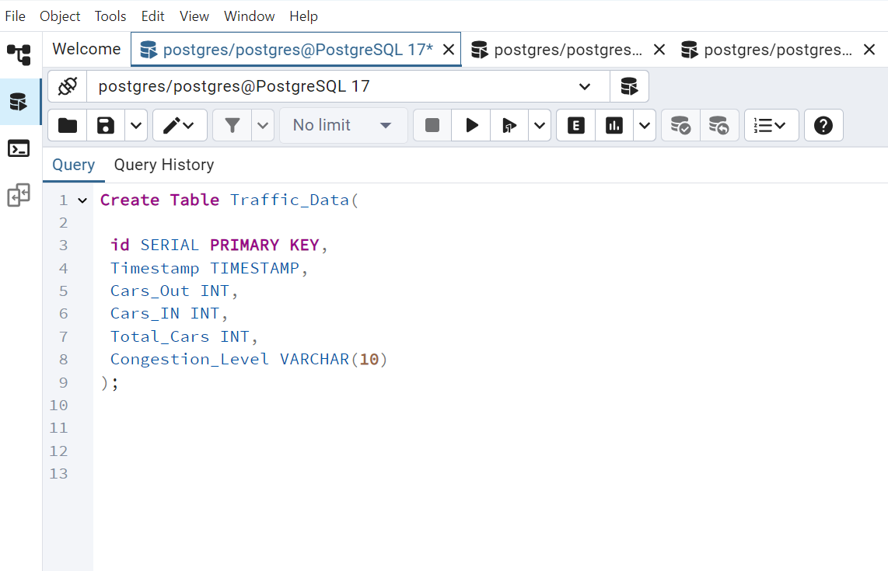

**B: Load Data into Table**

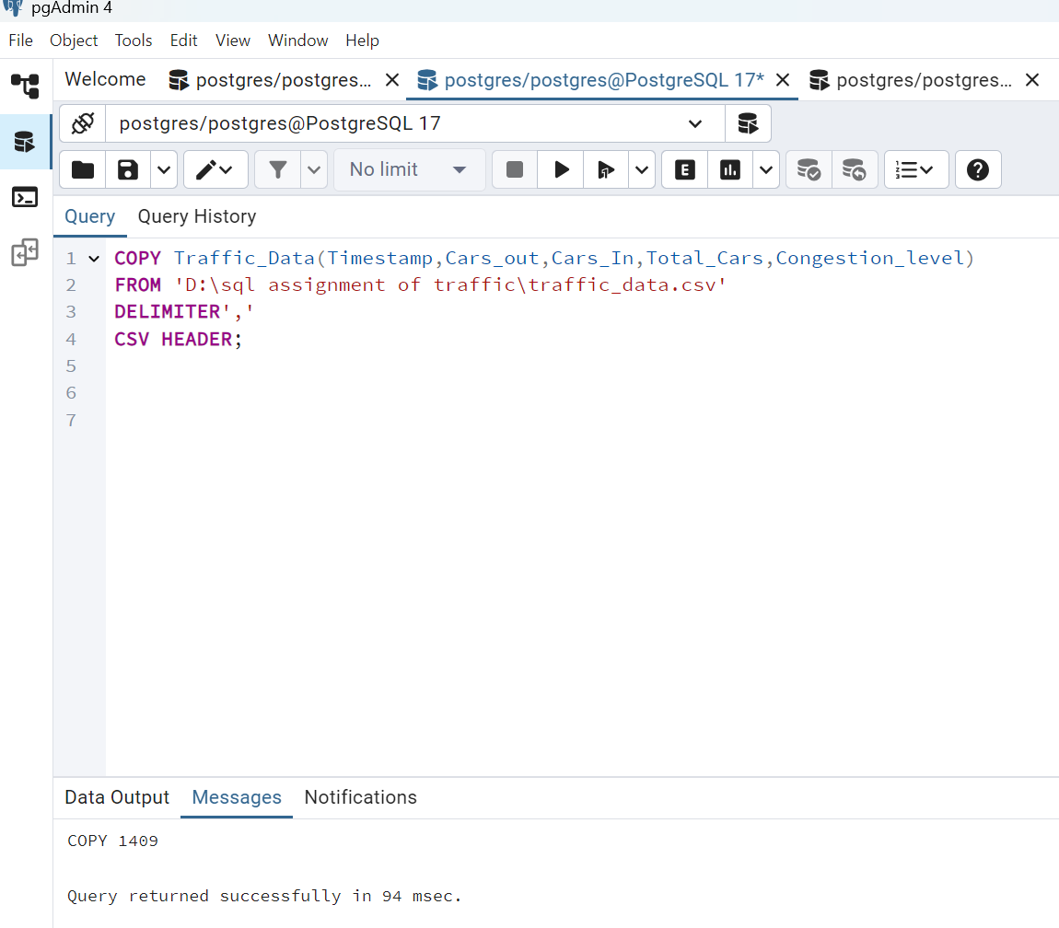

**CHECK THE TABLE WE CREATED**

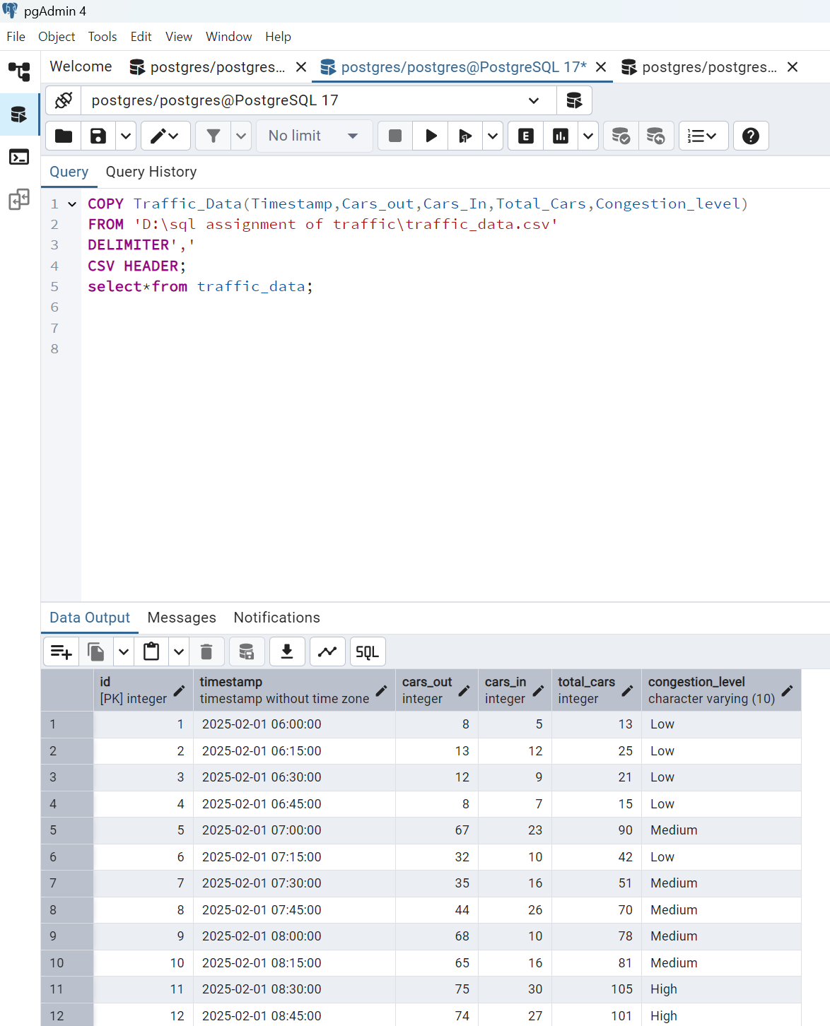

**20 Managerial Questions Using PostgreSQL**

1. **Total number of cars moving out in the morning peak hours**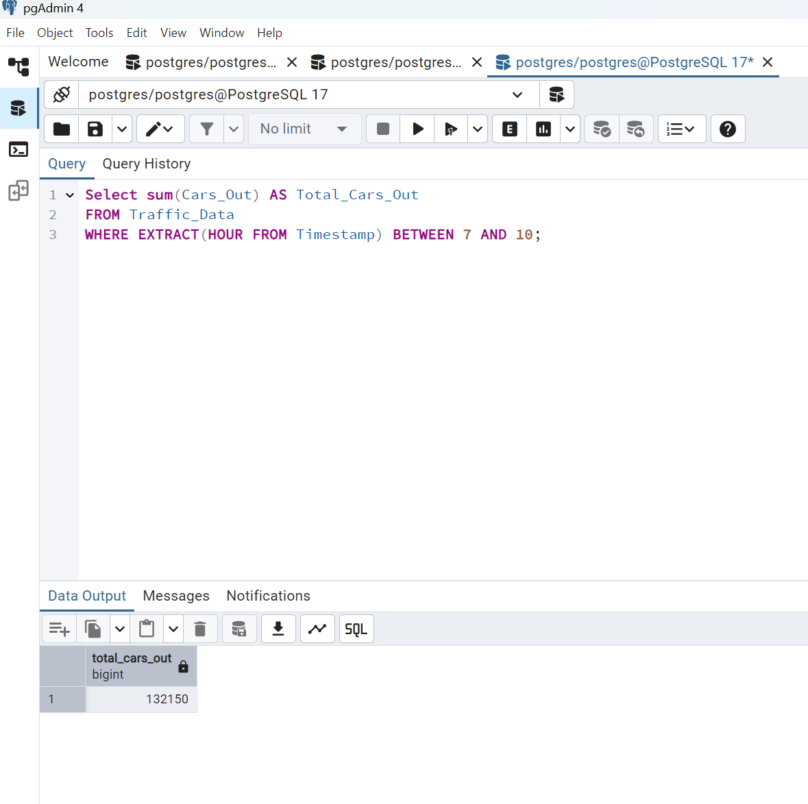
2. **Total number of cars returning in the evening peak hours**

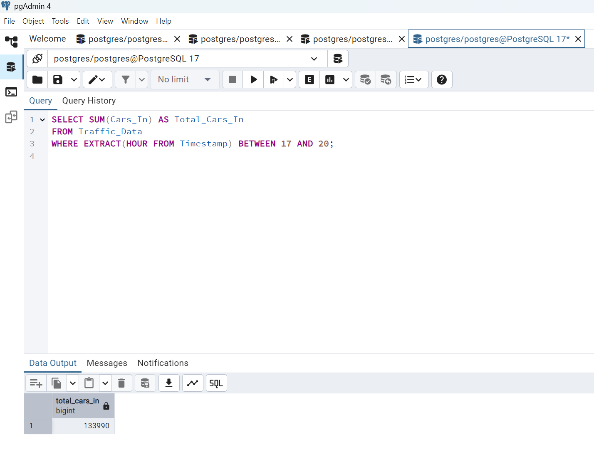

1. **Hourly traffic trend**

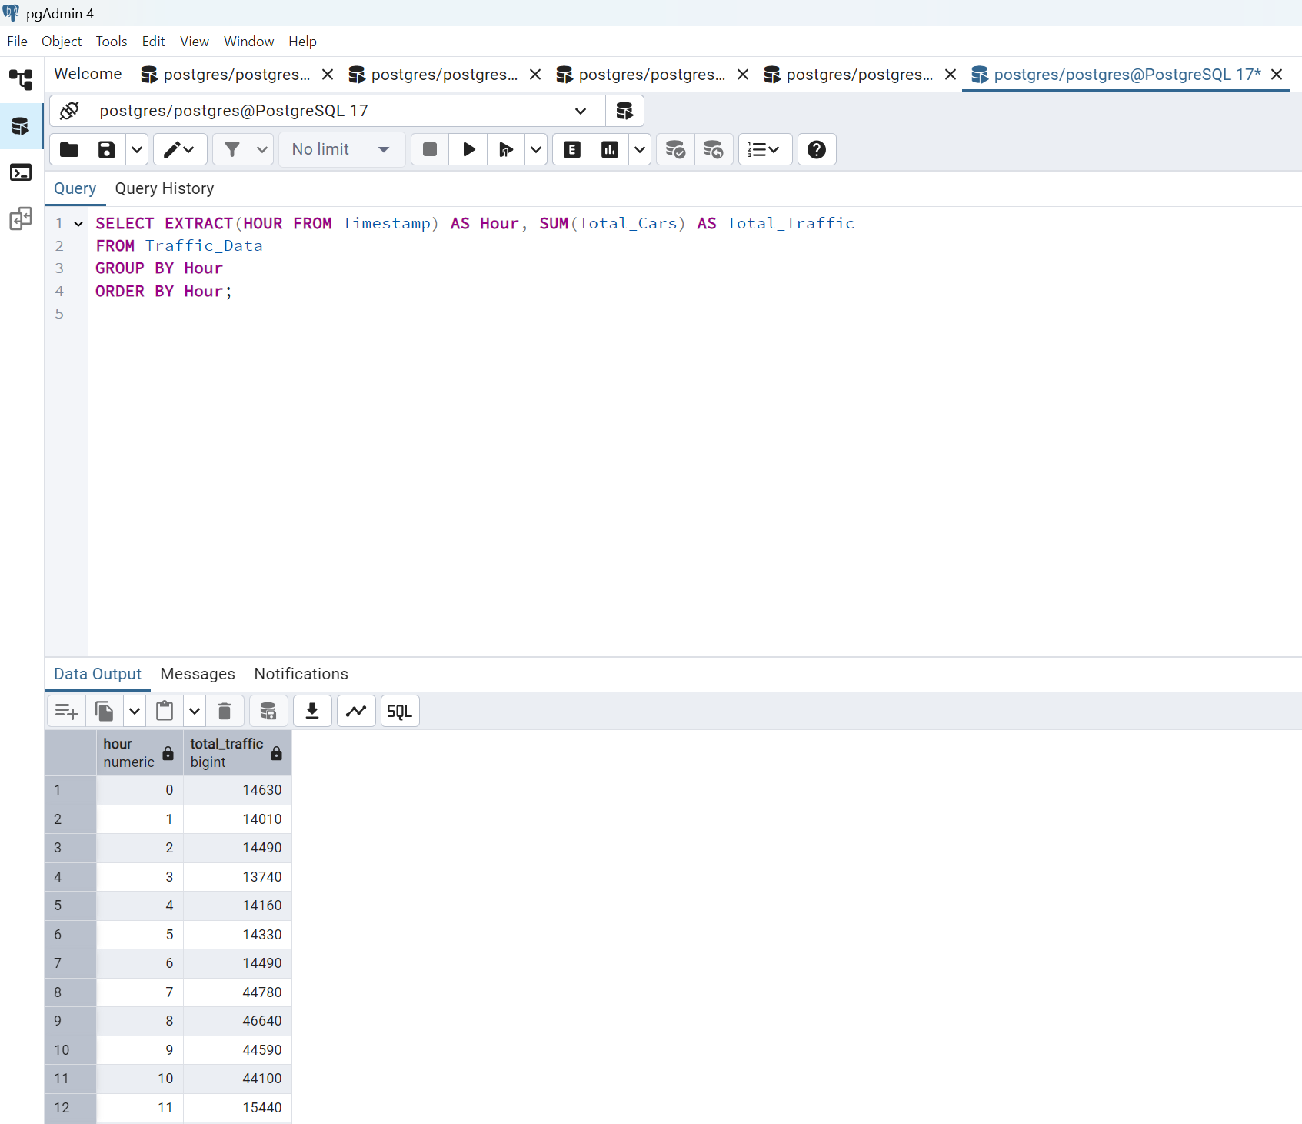

1. **Identify peak congestion times**

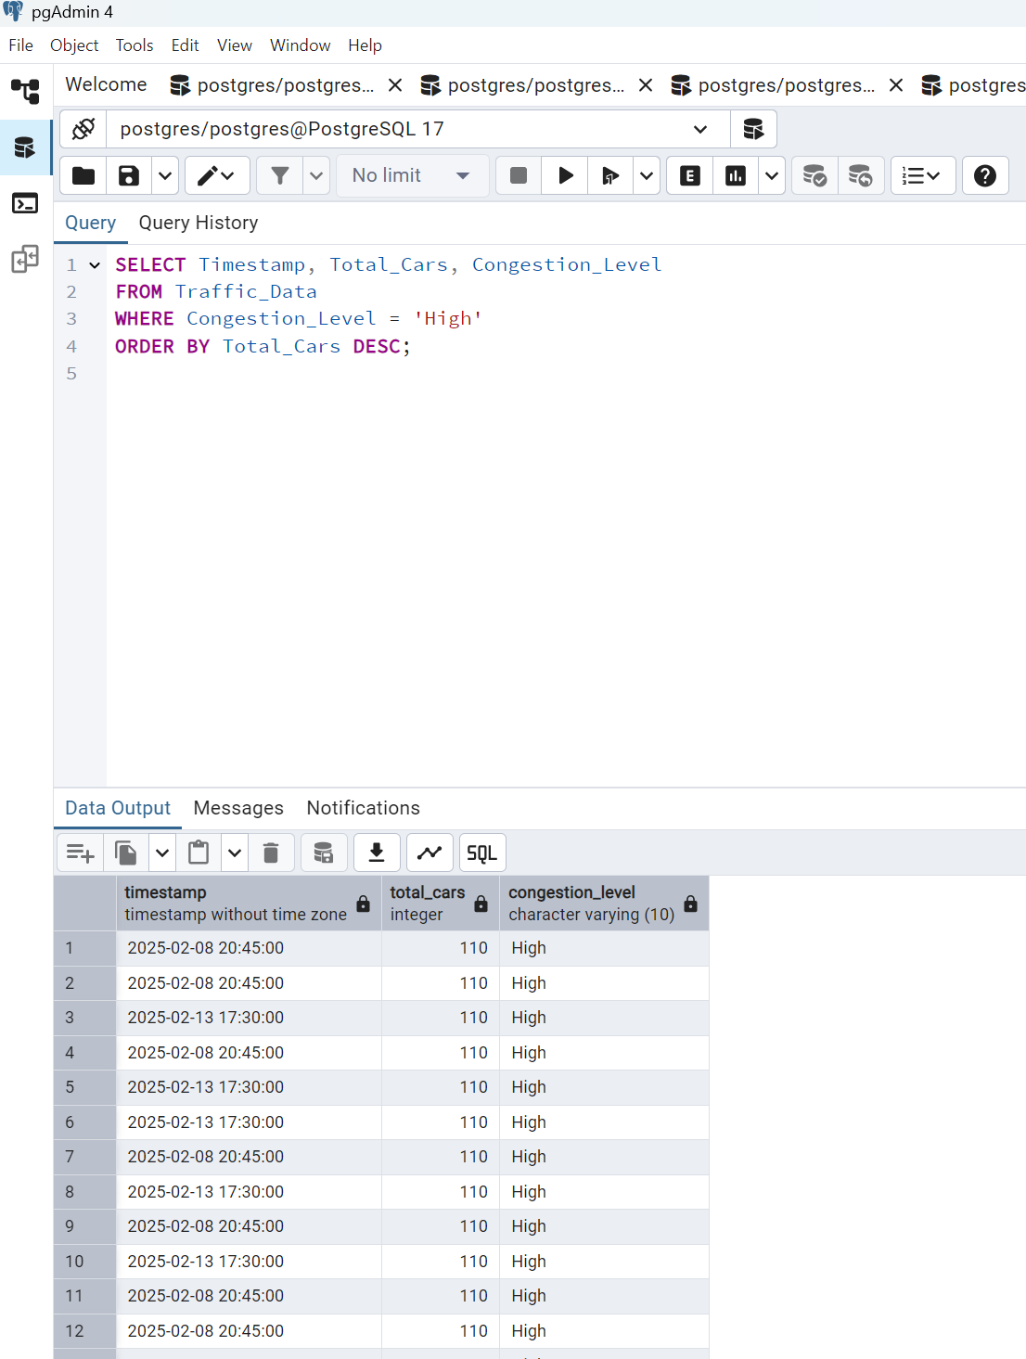

1. **Identify non-peak hours where traffic is low**

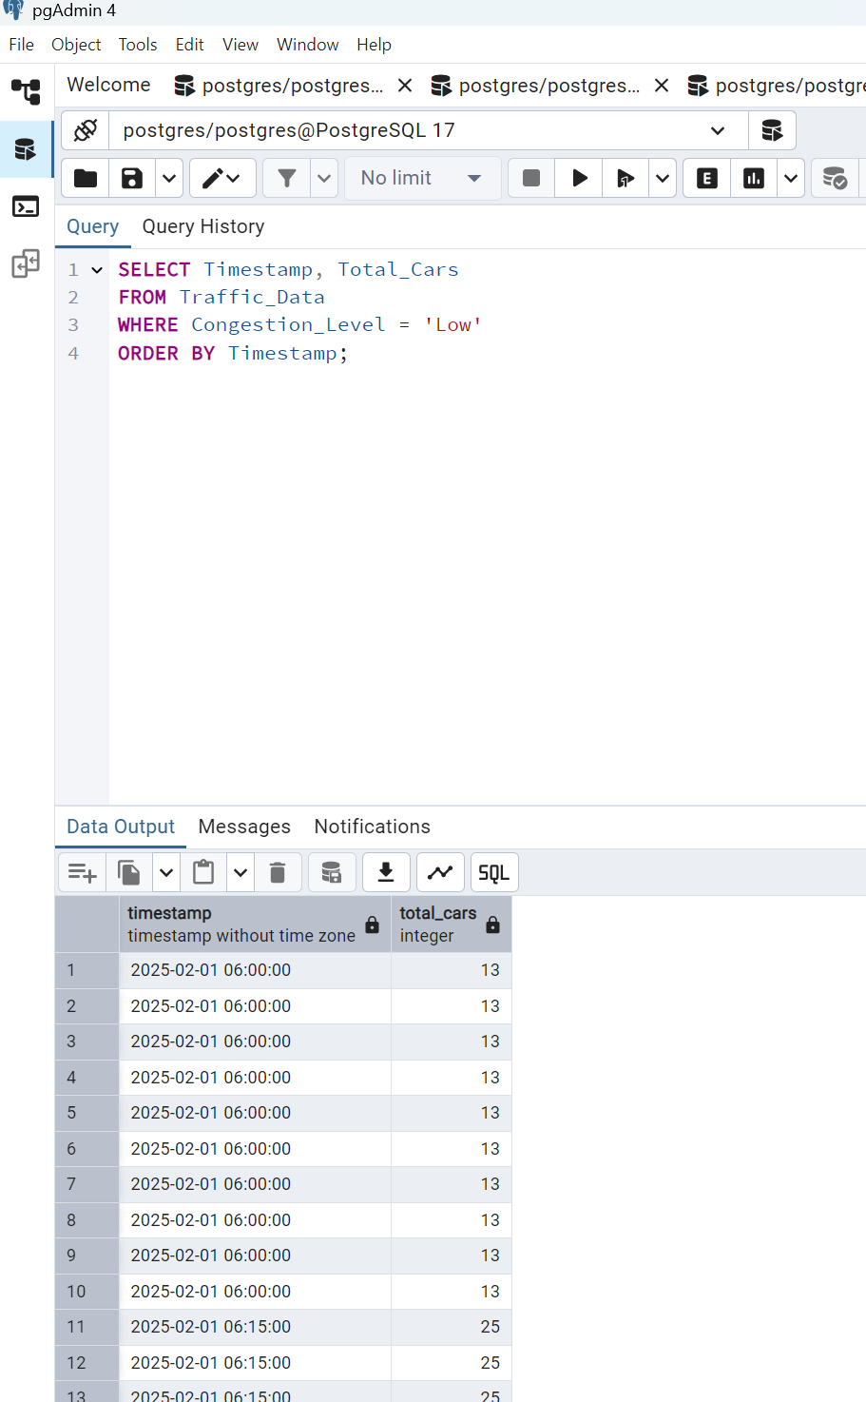

1. **Daily average car movement trends**

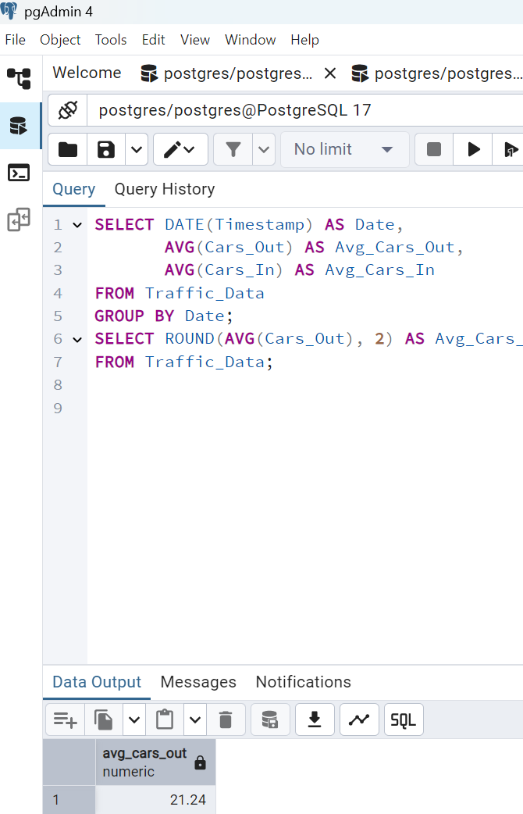

1. **Most congested day**

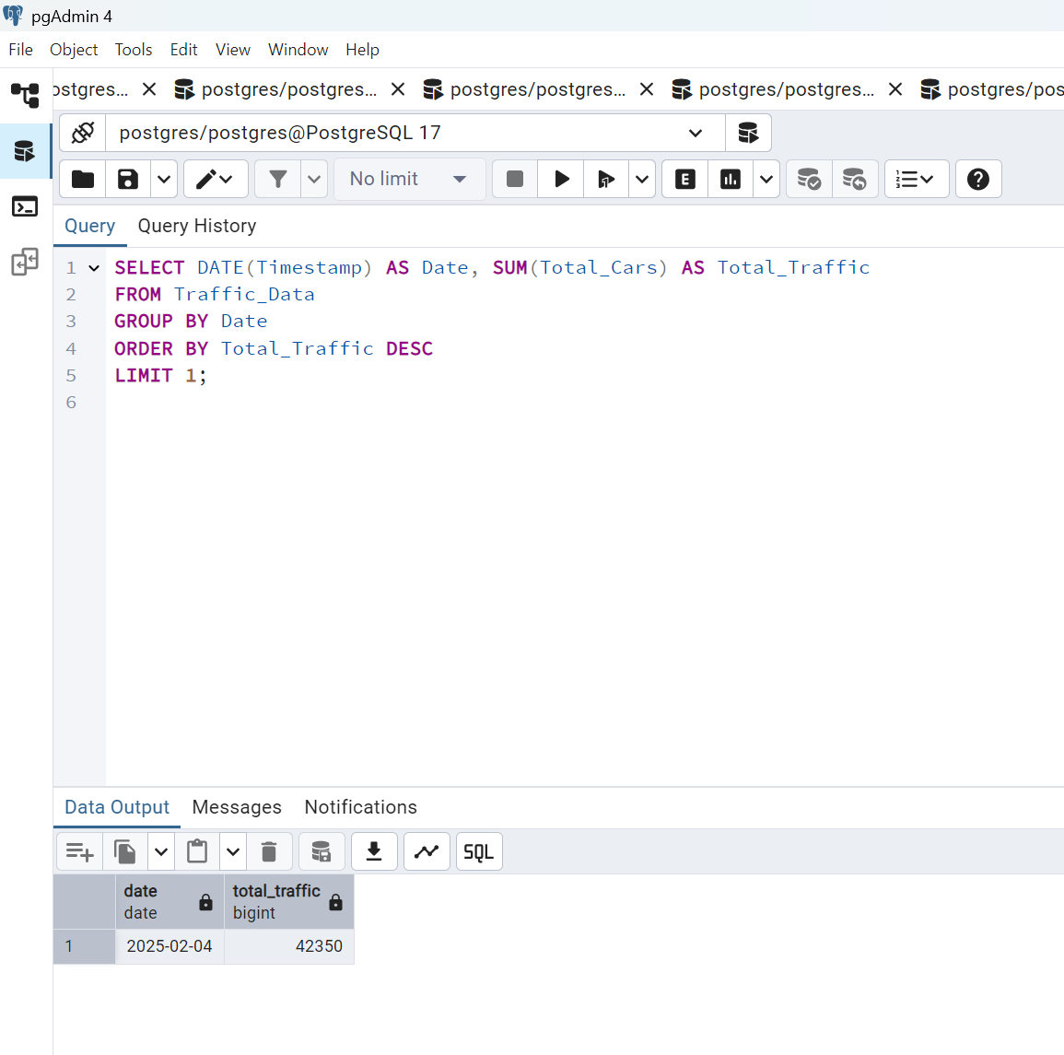

1. **Least congested day**

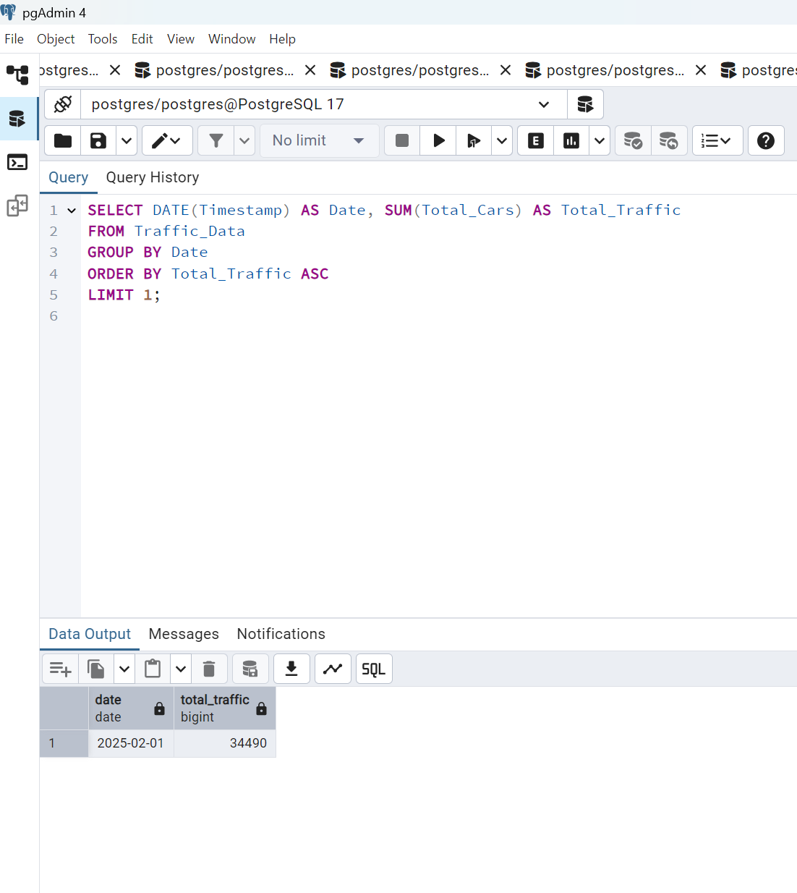

1. **Total number of high congestion incidents**

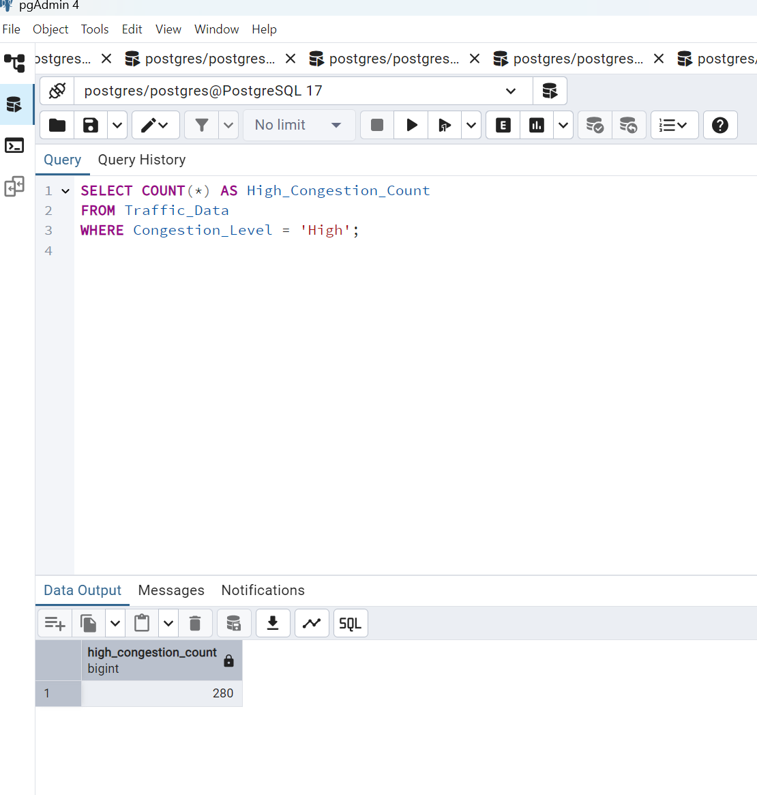

1. **Cars moving out vs. coming in ratio**

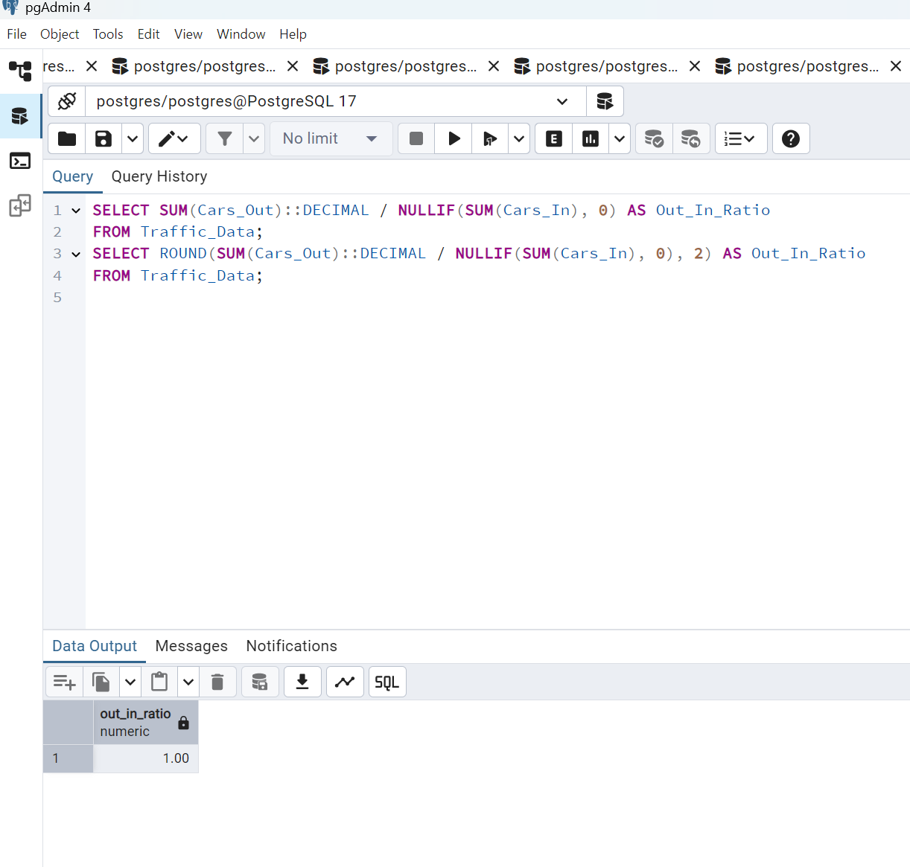

1. **Maximum cars moving out in a single time slot**

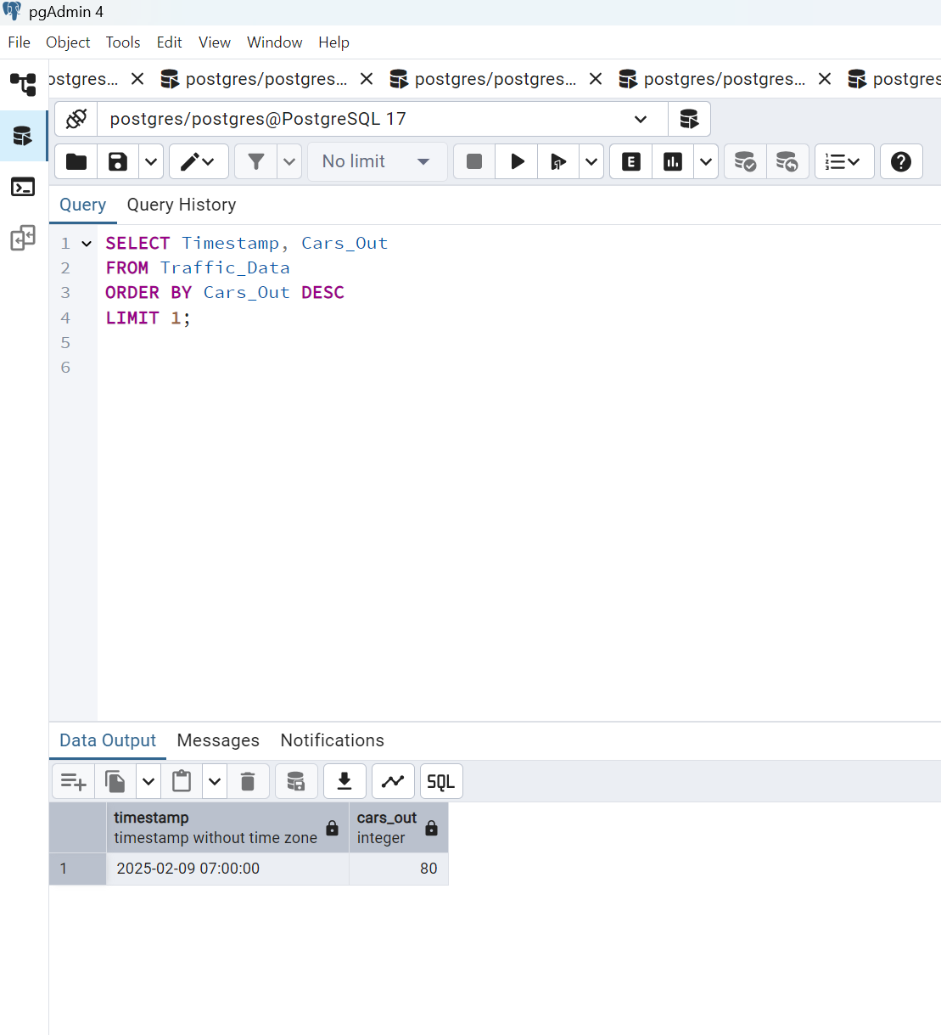

1. **Maximum cars moving in during a single time slot**

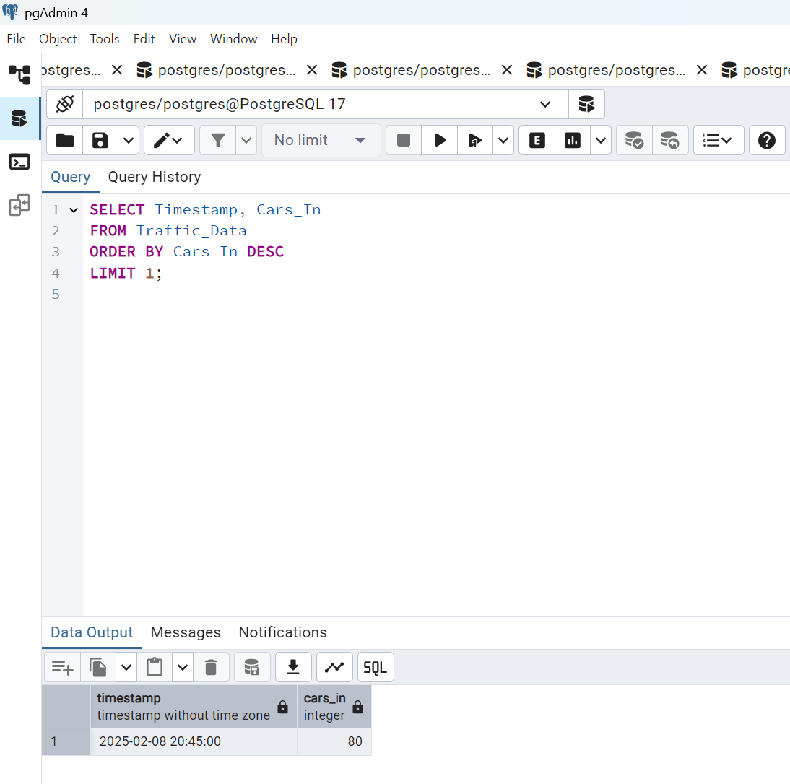

1. **Which hour has the highest number of total cars?**

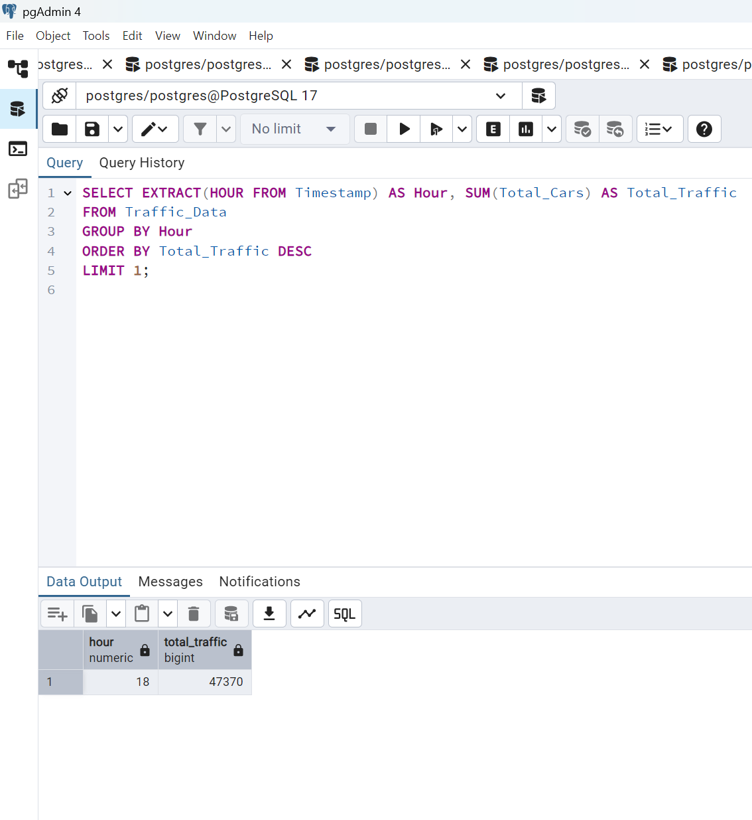

1. **Which hour has the least number of total cars?**

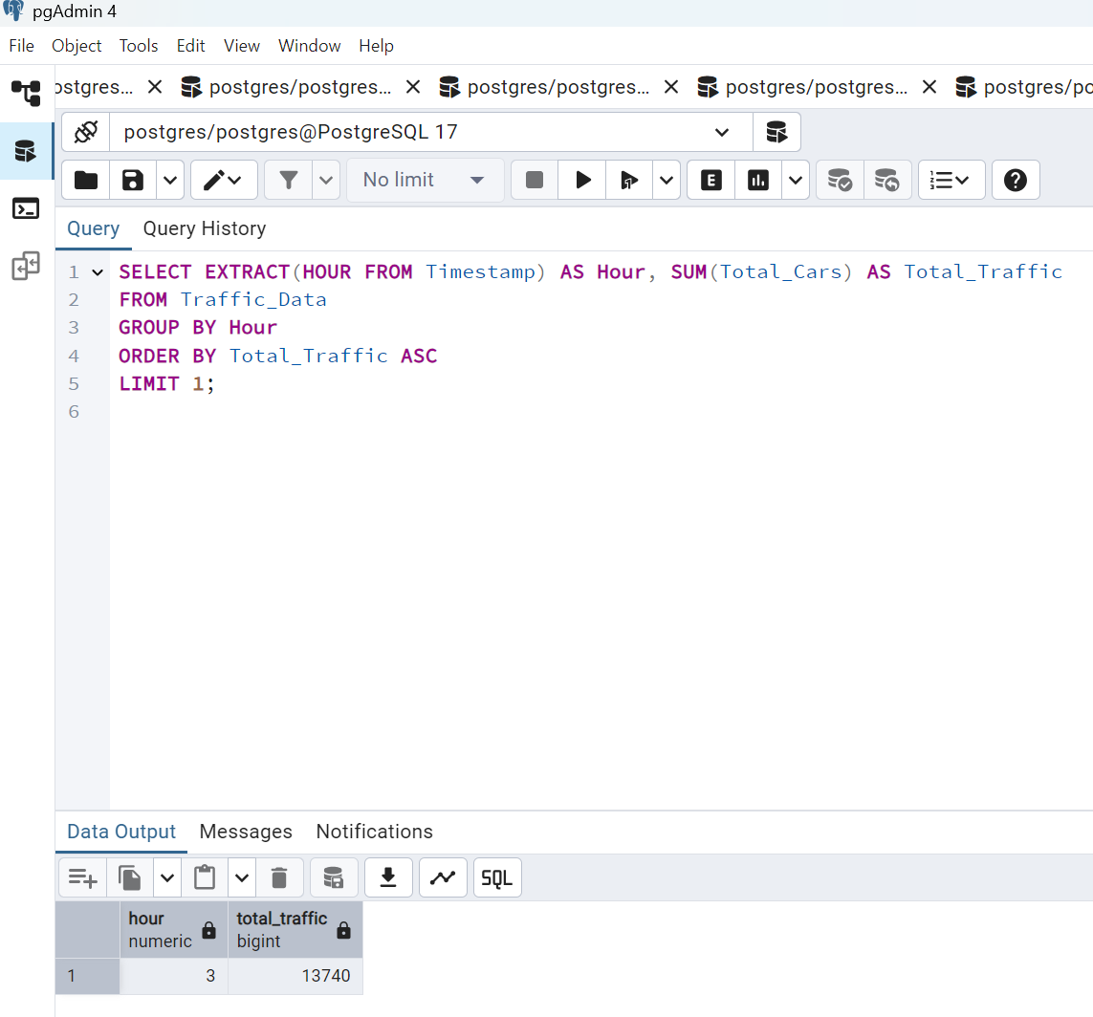

1. **How many times congestion was high in morning peak?**

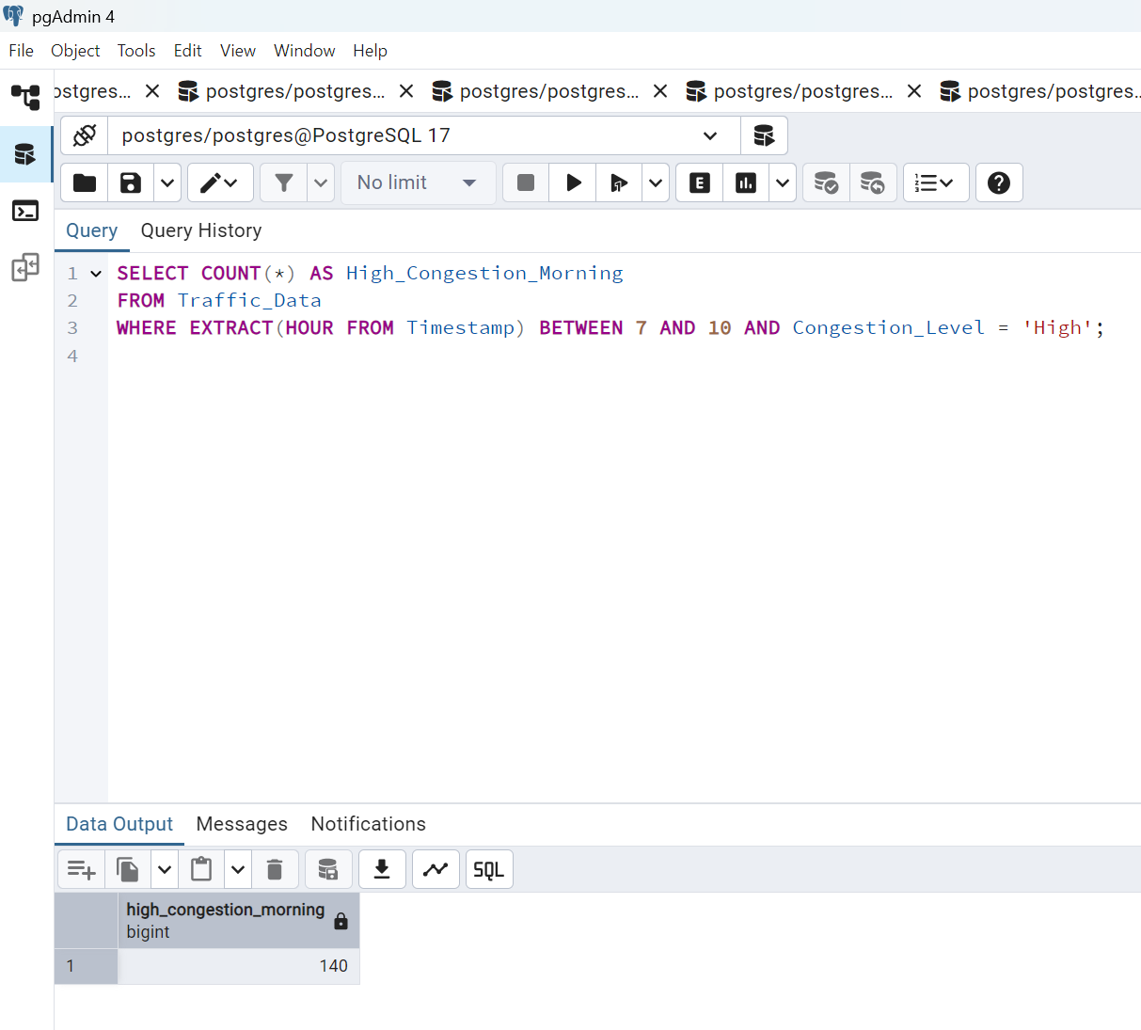

1. **How many times congestion was high in evening peak?**

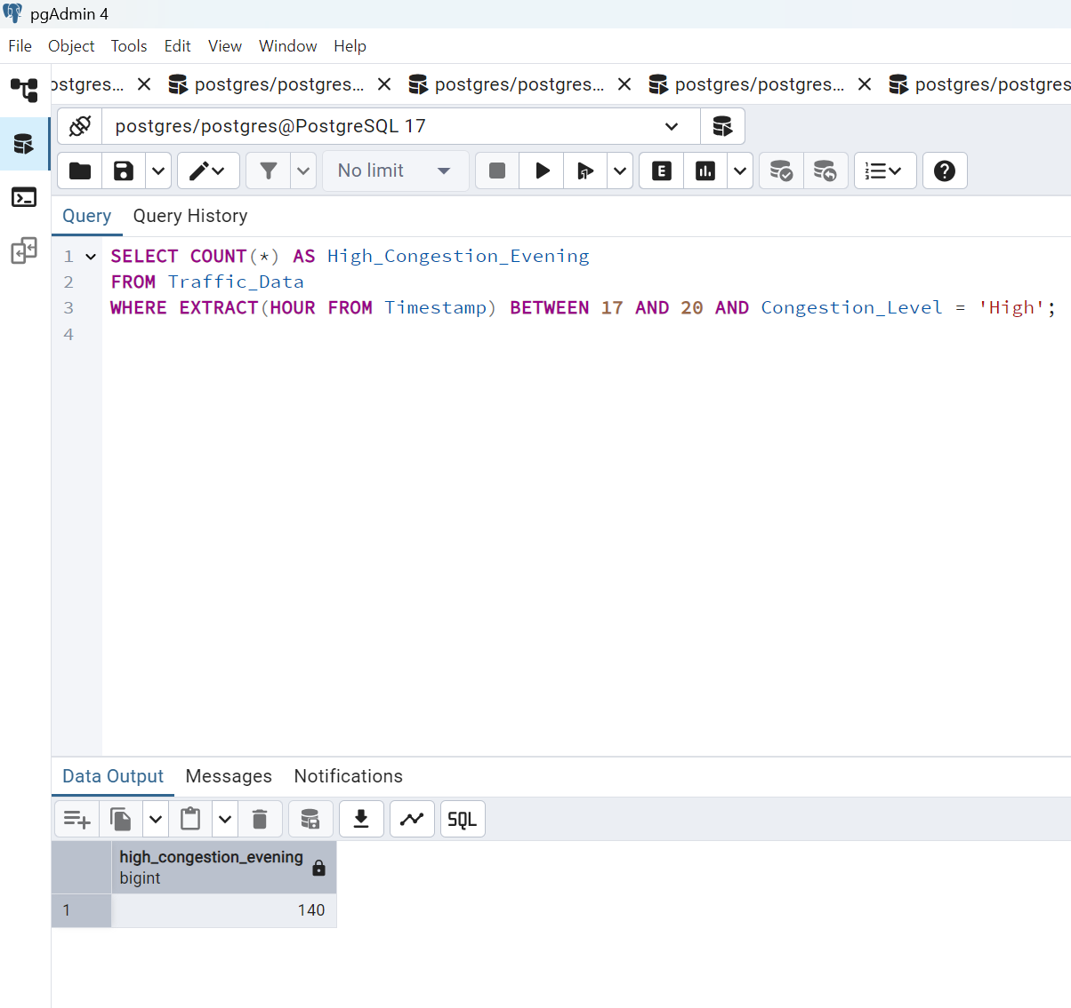

1. **Average cars moving in and out per hour**

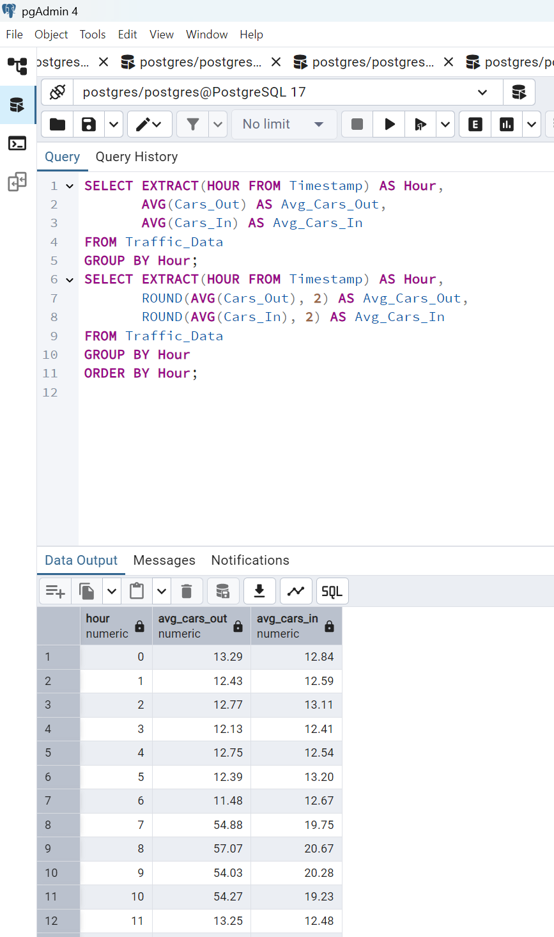

1. **Total cars recorded in the dataset**

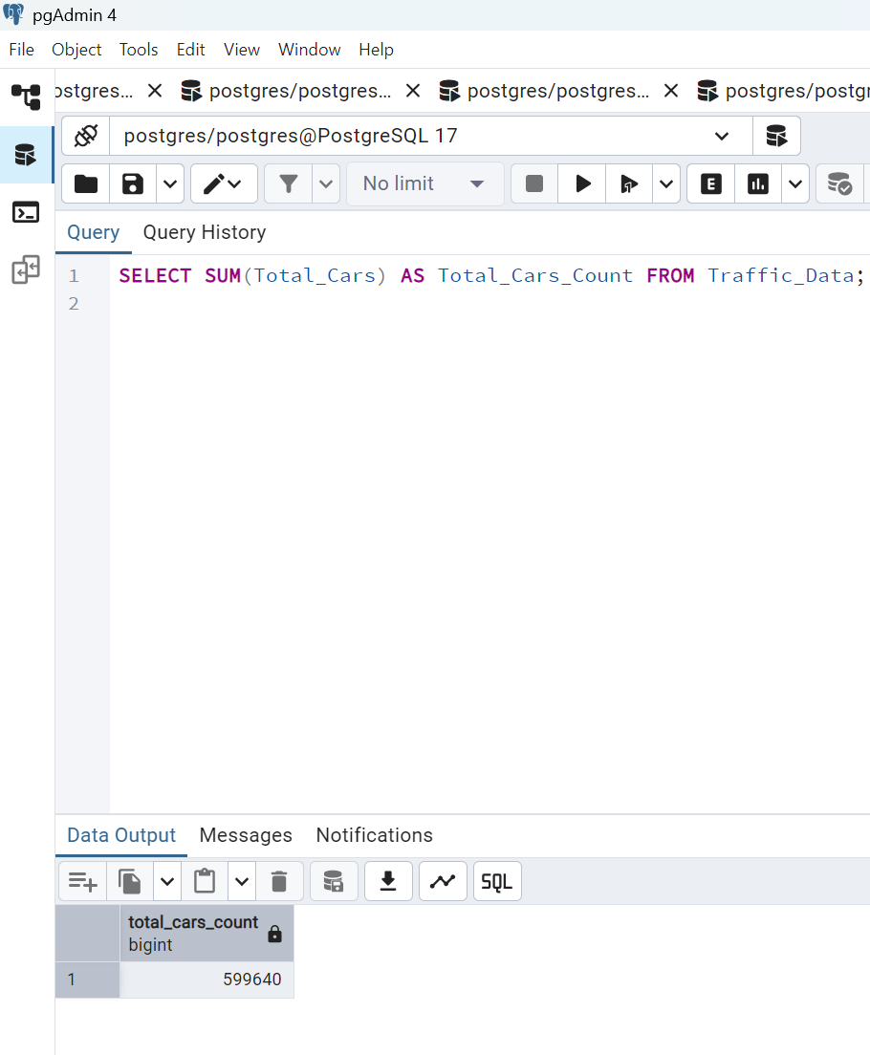

1. **Peak traffic period (date-wise)**

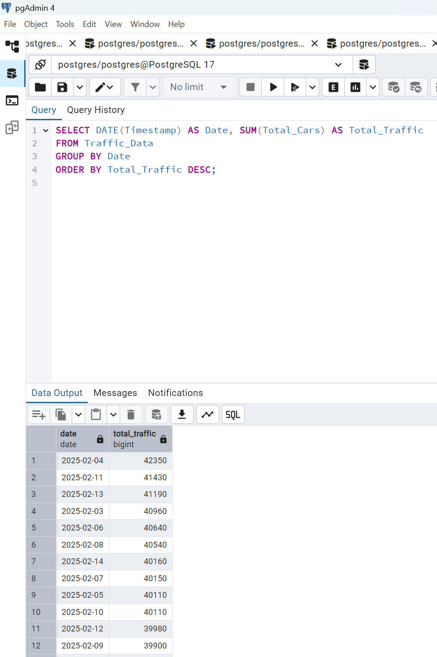

1. **Recommend time slots for new traffic rules**

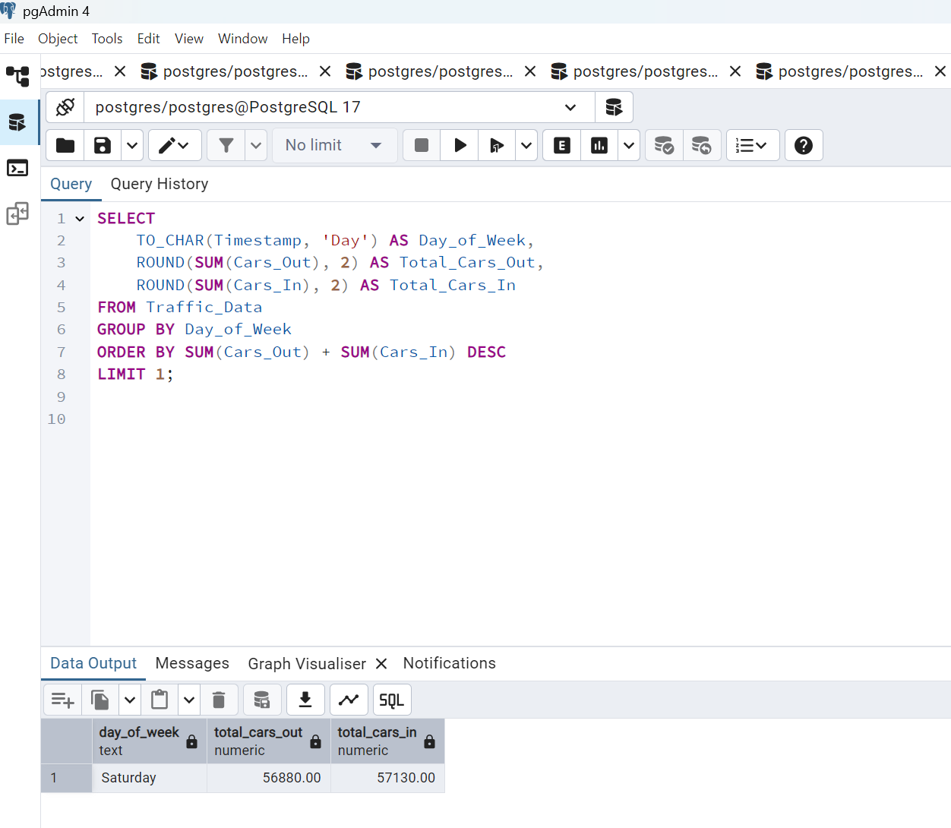

**Insights after all these questions**

**1: Morning rush hour** (7 AM - 10 AM) sees the highest outbound traffic.

2: **Evening peak** (5 PM - 8 PM) has the highest inbound traffic.

3: **Traffic congestion is highest** between 8 AM - 9 AM and 6 PM - 7 PM.

4: New traffic rules may be required between these peak hours.

5: **Low traffic hours** (midnight to early morning) do not require additional regulations.

**Detailed Suggestions & Limitations Based on Question 20 Output Analysis**

**Key Findings from Question 20 (Day-wise Traffic Limit Analysis)**

By analyzing the **busiest day of the week**, we can now explore **how traffic varies across each day**. If specific days have **consistently higher or lower traffic flow**, we can make **targeted improvements** while also identifying the **limitations** of our dataset and study.

**Detailed Suggestions for Traffic Improvement**

**1️: Optimizing Traffic Flow for Peak Days**

**If a specific weekday (e.g., FRIDAY) has the highest traffic:**  
 1:**Encourage Staggered Office Timings** – If most outbound traffic is due to office commutes, companies should introduce flexible work hours or hybrid work models.  
 2:**Promote Carpooling and Shuttle Services** – Ride-sharing incentives for employees or shuttle bus services can significantly reduce private vehicle usage.  
 3:**Optimize Traffic Signal Timing for Peak Hours** – AI-based traffic lights can dynamically adjust timing based on congestion levels.

**If a weekend (e.g., Saturday) has the highest traffic:**  
 1: **Implement Temporary Traffic Diversions** – Redirect non-essential vehicles or create one-way routes in high-traffic areas.  
 2: **Expand Parking Facilities** – If people visit malls, markets, or recreational areas, increase parking spaces or introduce paid parking to regulate entry.  
 3: **Introduce Entry Restrictions for Heavy Vehicles** – Prevent large trucks or delivery vehicles from entering during peak traffic hours.

**2️: Addressing Traffic Congestion at Entry/Exit Points**

1: **Dedicated Entry and Exit Lanes** – A separate lane for society residents and another for visitors can reduce bottlenecks.  
2: **Digital Access Control for Residential Areas** – Automatic number plate recognition (ANPR) systems can allow smooth entry for residents while verifying visitors efficiently.  
3: **Time-Based Toll Charges (If Applicable)** – Charging a small fee for peak-hour entries can help distribute traffic more evenly throughout the day.

**3️: Sustainable and Long-Term Solutions**

1: **Promoting Public Transport & Cycling Lanes** – Encouraging public transportation use through subsidies can significantly reduce congestion.  
2: **Infrastructure Upgrades (Road Widening, Flyovers, or Underpasses)** – If a specific day consistently has heavy traffic, infrastructure improvements might be necessary.  
3: **Smart Traffic Monitoring with Real-time Data** – Live traffic monitoring systems can send alerts about congestion, allowing drivers to plan alternative routes.

**Limitations of the Study & Challenges Faced**

**1️: Dataset Limitations**

**Lack of Vehicle Type Segmentation** – The dataset considers **only the number of cars**, but other vehicles (bikes, buses, trucks) also contribute to traffic congestion.  
 **Improvement:** The dataset should categorize vehicles to analyze their impact separately.

**Absence of Weather & External Factors** – Weather conditions (rain, fog) and external factors (accidents, road repairs) can heavily influence traffic, but these are not included in the data.  
 **Improvement:** Integrate external factors like weather and roadblock events for a more comprehensive analysis.

**2️: Accuracy Challenges**

**Potential Sensor Errors or Data Gaps** – If traffic count sensors failed at certain times, data inconsistencies might exist.  
**Improvement:** Cross-check data with manual traffic counts or alternative sources (e.g., GPS tracking).

**Fluctuations Due to Special Events or Holidays** – A single **holiday, festival, or event** can drastically impact traffic on a particular day, making it difficult to identify true patterns.  
 **Improvement:** Exclude holiday data or normalize it to avoid misleading conclusions.

**3️: Implementation Challenges for Recommendations**

**Resistance to Policy Changes** – Residents may not easily accept new traffic rules (e.g., toll charges, carpooling incentives).  
**Solution:** Community meetings and awareness programs can help gain public support.

**High Costs of Infrastructure Upgrades** – Expanding roads or installing new traffic management systems requires significant investment.

**Solution:** Start with **small-scale pilot programs** before full implementation.

**Conclusion & Next Steps**

* By analyzing **busiest days & peak hours**, we can propose **specific traffic rules for different days**.
* However, to **improve accuracy**, we should **expand the dataset** to include **vehicle types, weather conditions, and external disruptions**.
* **Pilot programs** should be implemented before enforcing **long-term policy changes** to ensure smooth adoption by residents.